Brief Introduction

This section of the report analyses all six algorithms covered in Exercise 2 and 3 on the same eight submodular optimisation problem instances used previously (MaxCoverage and MaxInfluence).
Each algorithm has been executed 100,000 fitness evaluations and repeated 30 times to determine if additional budget leads to an improvement in the performance of algorithm.
The results are then compared with those obtained in 10,000 evaluations.

Problem Instance 2100

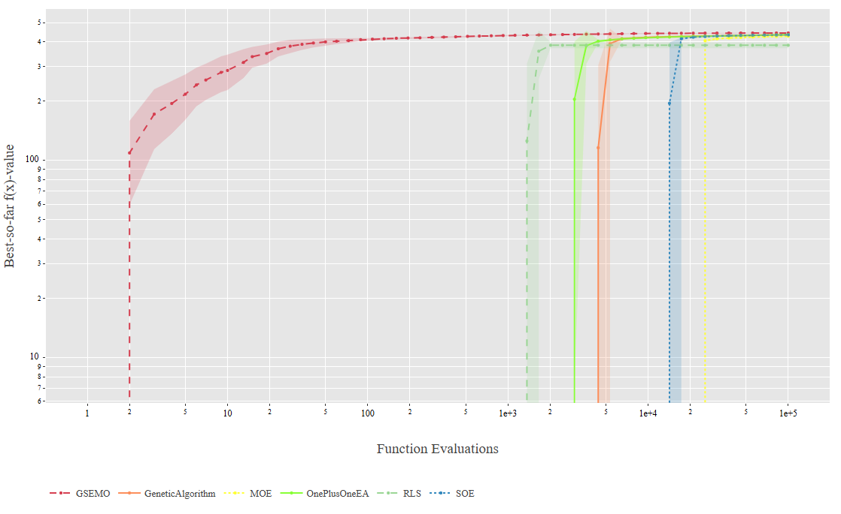

Observation :- The plot shows that GSEMO reaches the highest fitness value earliest and maintains a stable curve with minimal variance. RLS and Genetic algorithm both rise sharply after a short delay and quickly approach similar final fitness levels, with RLS converging faster. (1+1) EA and SOE evaluations improve more gradually. MOE remains the slowest, increasing steadily but at a lower overall rate. Variance across all algorithms decreases after approximately 10,000 evaluations, indicating consistent convergence behaviour.

Improvements :-

Problem Instance 2101

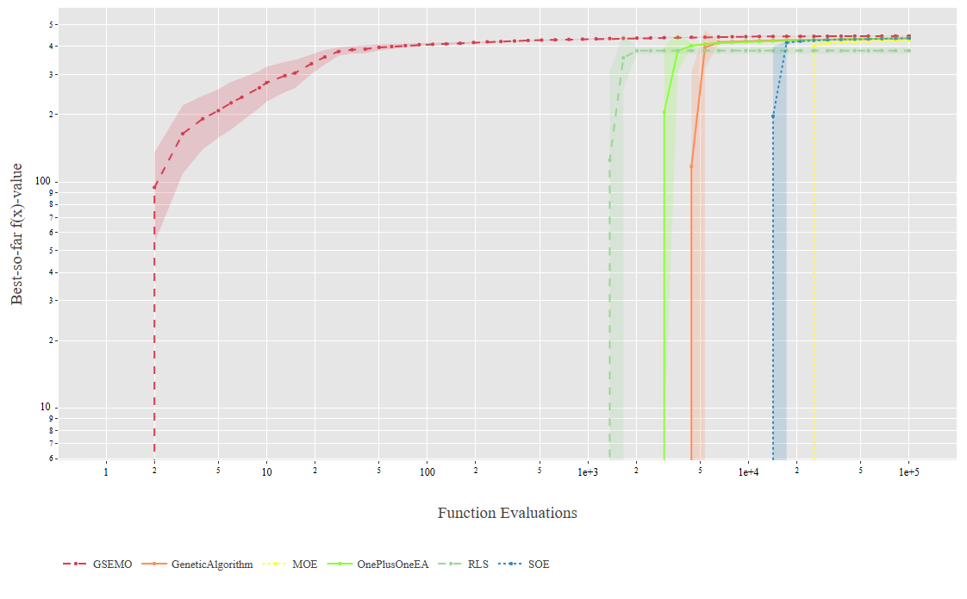

Observation :- All algorithms show clear convergence trends with extended evaluations. GSEMO again achieves the highest fitness value early on just as before and maintains a consistent lead with minimal variance. The Genetic Algorithm and RLS stays close, both showing steep improvement phases before peaking near GSEMO’s performance level. The (1+1) EA and SOE also reach high fitness values but at a slower rate and with slightly greater variance. MOE continues to perform the weakest, converging to lower fitness values and showing little further improvement even with increased budget. Overall, the curves indicate that most algorithms converge by around 10^4 - 10^5 evaluations, with reduced variability compared to the shorter 10, 000 evaluation runs.

Improvements :-

Problem Instance 2102

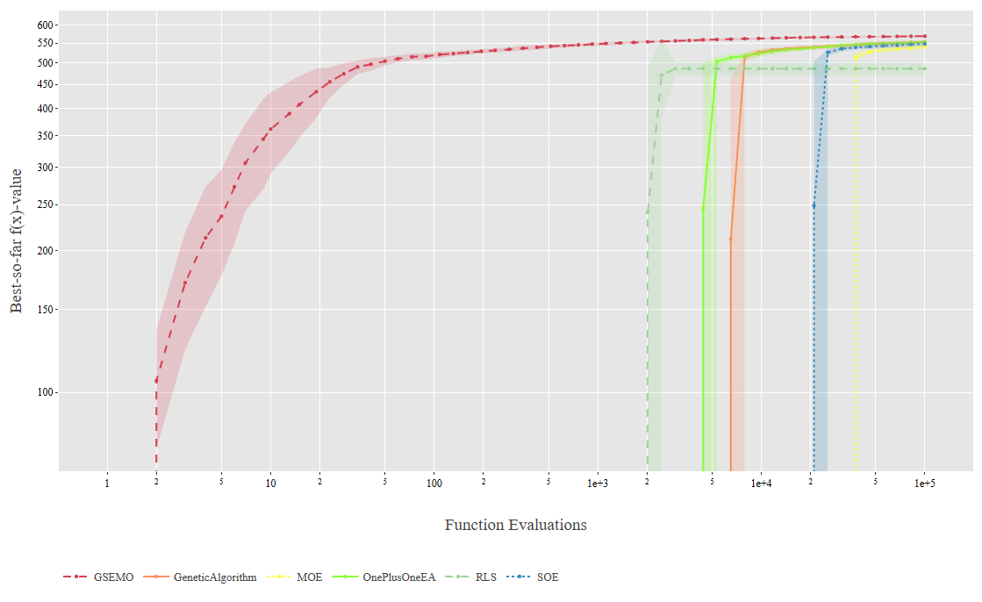

Observation :- According to the given plot, GSEMO again dominates just as other plots, achieving the highest fitness early and reducing with low variance. The Genetic Algorithm and RLS show rapid improvement after their initial phase, converging close to GSEMO’s final performance. Both maintain stable curves, indicating consistent convergence across runs. The (1+1) EA and SOE reach slightly lower fitness values and display moderate variance, with slower but steady improvement throughout the budget. MOE remains the weakest performer, increasing gradually but reducing below the other algorithms. Overall, most algorithms appear to have converged fully by roughly these evaluations, showing strong stability and little fluctuation beyond that point.

Improvements :-

Problem Instance 2103

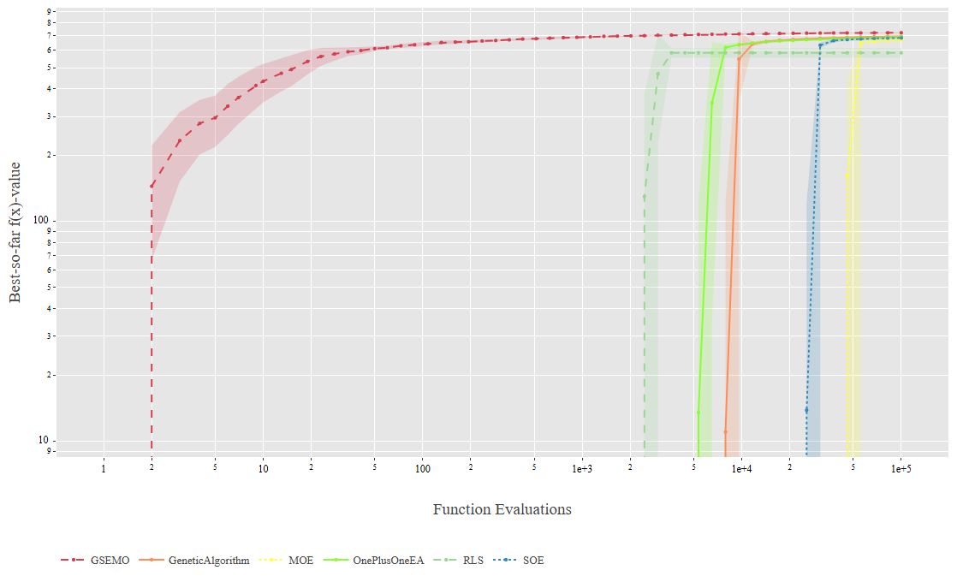

Observation :- All algorithms show clear convergence trends similar to the previous plots. GSEMO remains on the top, quickly reaching the highest fitness values early in the run and maintaining a smooth, stable curve with low variance. The Genetic Algorithm and RLS again follow closely, showing rapid move after their initial phase and converging near GSEMO’s final fitness level. The (1+1) EA and SOE display slower but steady progress, reaching just below the top algorithms. MOE continues to perform the weakest, showing the slowest rate of improvement and the lowest final fitness value. Variance across all algorithms reduces radically toward the end of the run, indicating strong convergence stability at higher evaluation budgets.

Improvements :-

Problem Instance 2200

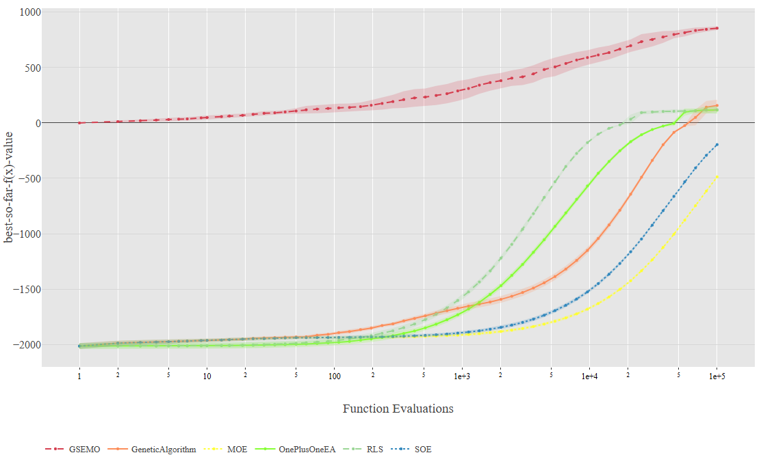

Observation :- All algorithms show in this plot have big difference in performance. GSEMO again demonstrates clear dominance, achieving positive fitness values early in the run and maintaining steady improvement across the full evaluation range. Its curve rises smoothly, consistently outperforming all others. The Genetic Algorithm, RLS, and (1+1) EA each show gradual improvement, approaching values close to GSEMO near the end of the constraint. The SOE and MOE algorithms fall behind throughout most of the run, improving later but remaining below the top performing methods.

Improvements :-

Problem Instance 2201



Observation :- In the following plot, GSEMO maintains a strong lead throughout the entire run, steadily improving and achieving the highest final fitness value with low variance across various evaluations. The Genetic Algorithm and RLS both show consistent upward growth, gradually closing the gap to GSEMO near the end of the evaluation budget. (1+1) EA and SOE follow similar improvement patterns. MOE again falls behind, displaying slower and smaller gains with limited variance. All algorithms demonstrate smoother convergence and tighter spread compared to the earlier 10, 000 evaluation results, confirming stable behaviour with increased evaluation time.

Improvements :-

Problem Instance 2202



Observation :- For the above instance, the results are again similar to earlier MaxInfluence cases. GSEMO achieves the highest and most stable fitness performance, maintaining a smooth upward trajectory throughout trials. The Genetic Algorithm and RLS follow closely behind, both demonstrating strong improvements that nearly reach GSEMO’s performance toward the end of the budget. The (1+1) EA and SOE improve more slowly, achieving moderate final fitness values, while MOE remains the lowest performer with limited progress across evaluations. All algorithms show smoother and more stable convergence compared to their 10,000 evaluation runs, indicating that the extended evaluation time promotes more consistent optimisation behaviour and reduces variance.

Improvements :-

Problem Instance 2203



Observation :- In the following pattern, GSEMO continues to outperform all other algorithms, achieving the highest fitness values with a smooth curve. It consistently improves throughout the evaluation budget and maintains a clear lead over the rest. The Genetic Algorithm, RLS, and (1+1) EA show comparable paths, each improving after an initial slow phase and approaching GSEMO’s performance near the later stages. SOE performs moderately well but remains behind, while MOE continues to show the weakest performance overall, showing slower progress and lower final fitness. This plot indicates more reliable convergence behaviour with longer evaluation time.

Improvements :-

